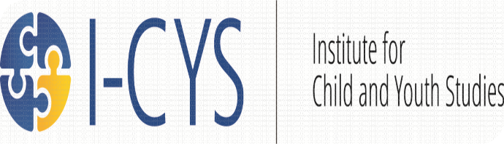

Events: 2015/2016

Graduate Student Event | Friendly Feedback Session | October 16th  3:00 pm-C450
Graduate Student Event | Beers/Chat Session | October 30th  3:00 pm-C450
Graduate Student Event | Friendly Feedback Session | November 6th  3:00 pm-C450
Graduate Student Event | Friendly Feedback Session | November 27th  3:00 pm-C450
Graduate Student/  Faculty Event | Care Work Seminar | December 11th  3:00 pm-C450
Carmen Nielson Lecture | Was Anne Brown really  the “Mother of  Confederation”?  Re-Reading George  Brown’s love letters | January 15th  3:00 pm-L1050
Erin Spring Lecture | Freedom, Restriction and the Navigation of  Adolescent Space: A Comparison of Two  Migrant Experiences |  | January 18th  7:30 pm  Lethbridge  Public Library
Nick Morwood Lecture | Imposed Innocence, the End of Society, and Our Posthuman Future: Exploring the Role of the Child in Post-Apocalyptic and Dystopic Fiction and Film |  | January 29th  3:00 pm C640
Will Pratt Lecture | The Stoney Nakoda, Reverend John McDougall and The McDougall Orphanage,1883-1908 |  | March 4th  3:00 pm L1050
Allyson Stevenson Lecture | Reproducing Indigenous Nationhood, Redefining Reproductive Justice: Strategies of the Saskatchewan Native Women’s Movement (SNWM) in the 1970s |  | March 10th  12:30 pm Andy’s Place
The Pass System | Free Movie Screening |  | March 14th  7:00 pm PE250
Graduate Student Event | Friendly Feedback Session |  | March 18th  3:00 pm C450
Art Exhibit | Raising Spirit: The Opokaas’in Digital Storytelling Project |  | March 5-19th  Park Place Mall
Community Art Reception | Raising Spirit: The Opokaas’in Digital Storytelling Project |  | March 21st  5:00 pm Opokaas’in Early Intervention Society
For more information, please email: icys@uleth.ca or call (403)329-2551

