Adding a signature with Adobe Reader
Save a copy of the form to your local computer or network
Click on Fill & Sign

Fill in all applicable areas of the form
Click on the Sign Icon at the top and Click Add Signature
Type your name in the box and click Apply
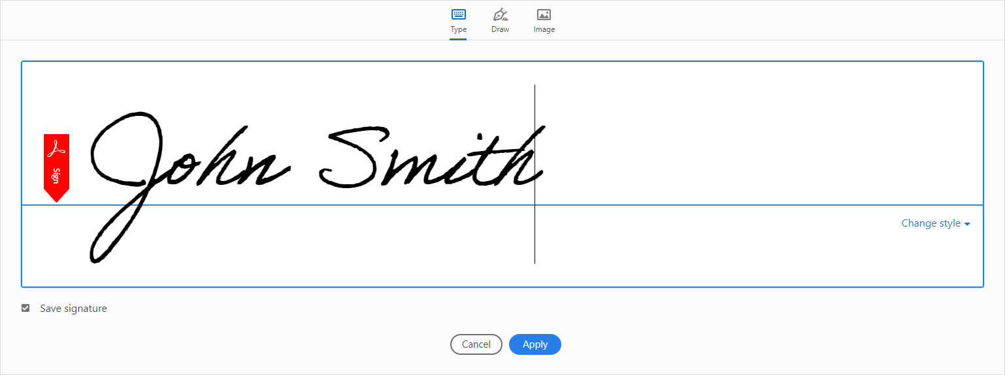
This will create a floating signature
Move your mouse to the signature line of the document and drop (click to release the signature)
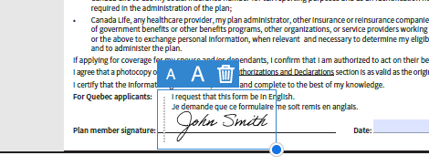
Save a copy of your document ( Message below will appear )
Click on Save a Copy

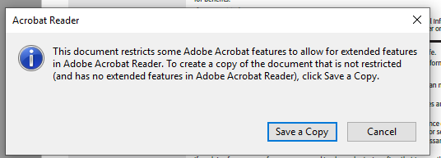

You must enter a new file name

Once the document is saved you can submit as per standard process (please retain a copy for your records)

