Campus Safety

EVENT FIRST AID PLAN GUIDELINES

First Aid Plans for special events should include a hazard assessment and an Event First Aid Plan which describes procedures for the provision of first aid during the event. The following should be considered:

- Number of people at the event (special considerations for first aid for over 200 people may include first aider in attendance or first aid stations depending on hazards/circumstances around event)
- Type of people at the event (example: predominantly children or predominantly elderly may require special first aid considerations)
- Site distance from medical assistance (more than 20 minutes travel time to medical aid is considered distant)
- Site location and configuration (example: type of building or outside environment may involve first aid planning specific to site)
- Activities occurring at event (example: dancing, board games, rugby)
- Duration of event (an all-day event or 24 hour event requires more first aid consideration)
- Service of alcohol
- Weather (rain, wind, etc.) considerations (in all event planning, weather hazards MUST be taken into consideration with planning for closure or change in venue for weather concerns)
- Other site-specific hazards
The First Aid Plan should be submitted to any governing safety bodies- at the University of Lethbridge the plan should be submitted to Campus Safety- Insurance & Risk Office. The minimum requirements of an Event First Aid Plan are:

1. A written plan to show that all event staff have been trained regarding the Event First Aid Plan, know the location of first aid services and supplies, and have access to functioning communication devices to summon assistance.
2. Ensuring adequate First Aid services for the size of the event. For example, some smaller events may request to utilize University of Lethbridge Designated First Aid Responders (SRS or Security Representatives) and existing first aid kits/AEDs. Other events may require external first aid medical standby service. Examples of such First Aid support services can be provided by St. John Ambulance Volunteer First Aiders or Medical Standby Services through SAFETYNETT Training Services.
3. A posting of pertinent First Aid Plan information at the event site and must include the following:
- The equipment, supplies, facilities, first aid attendants (including who is designated) and services available and their location,
- 9-1-1 Access includes the location of communication devices and how to call for first aid services,
- First Aid Stations are typically created for crowd expectations of 2,000 or greater with first aid staffing. Examples of a Medical Aid Station are a tent or a clinic. The aid station must have 9‐1‐1 communications capability which can include cell phones or approved radio contact. The aid station must be clearly marked as a First Aid Station (i.e., “First Aid Station 1”) through a sign. If there is more than one aid station at an event, the station sign should bear a number, and this should correspond to the location of the aid station on the map that is submitted. It is expected that Aid Stations will have adequate supplies. Consider designating a person to meet the emergency responders to guide them to the injured person.

The following is an example of First Aid information signage to be posted at a special event.

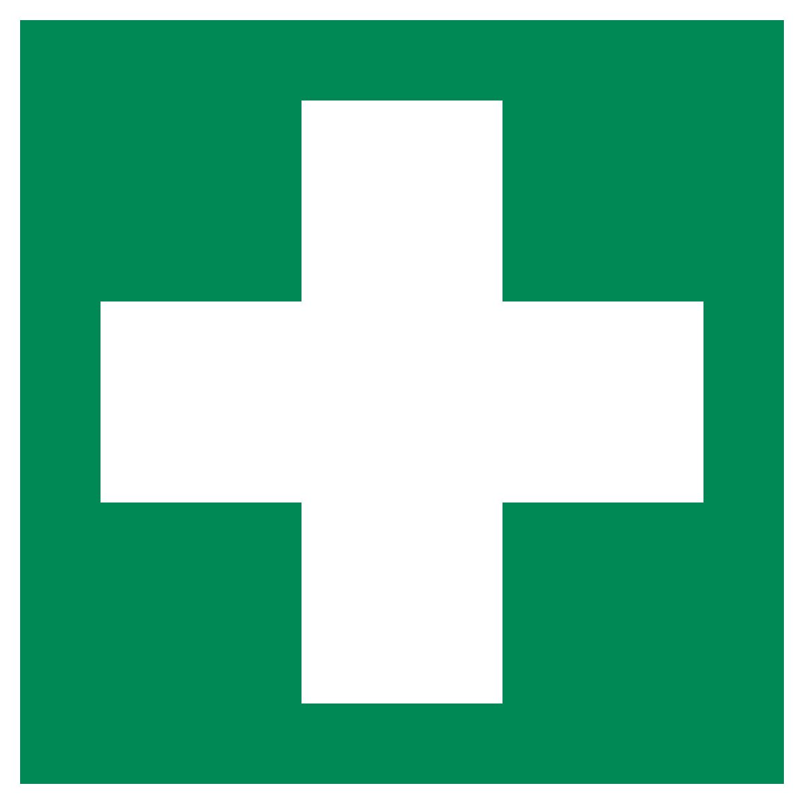
FIRST AID INFORMATION
Event: | “Event Name”
Date of Event: | January 31, 2019
Event Hours: | 7pm to 1am
FIRST AIDERS
(Name and Phone Number)
Or Contact *****
FIRST AID EQUIPMENT
First Aid Station Location
First Aid Kit Location(s)
AED Location(s)
Call 9-1-1 for Emergency Services Ambulance
Nearest Phone for Calling 9-1-1 is located at:

4. POST-EVENT REPORT
- Time, date and location of significant incident
- Record time of EMS call or pick-up and information about other first aid (and first aiders on site) given
- If a first aid event occurred during the event, ensure the First Aid Record is completed and submitted with CAIR report

5. Other sources of event planning information include:

- University of Lethbridge: Campus Safety Special Event Guideline
- Alberta Government: Setting the Stage
- Province of BC: British Columbia Major Planned Events Guidelines
- DC Department of Health: Special Events Health, Medical and Safety Planning Guide

