Work Type: Restricted Access to U of L Campus while working during a pandemic. | Location of Work: All U of L worksites | Date: 16/03/2020
Assessment completed by: |  | Reviewed/Revised: 26 March 2020

Activity/Task  (List all tasks and activities of the job/work) | Description of  Hazard  Note: There may be more than one hazard associated with an activity or task. | Likelihood (L) | Severity (S) | Risk Total = (L*S) | Rating (High, Moderate, Low) | Hierarchy of Hazard Controls  (OHS Code 2009, Part 2 section 9)  Elimination/Substitution (E/S) if this not an option the following hierarchy of controls is to be followed:  - Engineering Controls (EC)  - Administrative Controls (AC)  - Personal Protective Equipment (PPE) | 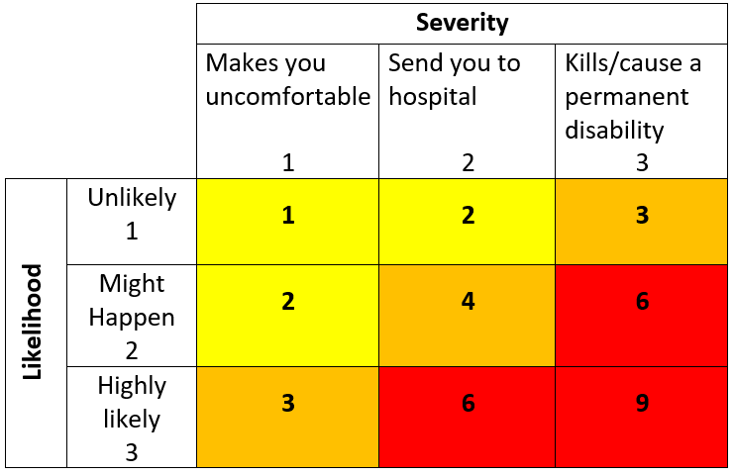  High Risk  Moderate Risk  Low Risk
Working Alone | -isolation  -lack of communication  in the event of emergency | 3 | 3 | 9 | H | EC: telephone, cell phone, radio, web camera  AC: training, organizing and planning work, rotation of workers, U of L working alone procedure and login system; check in/out procedure, registration, list of emergency contact phone numbers
Working under unusual or unfamiliar circumstances | Psychosocial hazards  -Stress/fatigue  -anxiety | 2 | 2 | 4 | M | EC: key/card control, restricted access  AC: restricted access approval and procedures, training, organizing and planning work, rotation of workers, take regular breaks, rotating/modified work schedules (if applicable), Employee Family Assistance Program (EFAP); list of emergency contact phone numbers
Campus awareness | -hazards associated property damage or maintenance required | 2 | 2 | 4 | M | AC: report property damage and/or maintenance, report to Security and Facilities Services.
Workplace contact with individuals (within 2 meters)
Security Services Reps - Emergency (first aid) response | - Probable exposure to viral airborne particles  - Probable exposure to viral particles on surfaces. | 3 | 2 | 6 | H | AC: Hand hygiene, respiratory etiquette, training, individuals who are ill will be kept away from workplace, respiratory fit testing and training.  PPE: gloves, safety glasses, splash guards, protective clothing, fit-tested respirators, as appropriate.
Health Centre | - Probable exposure to viral airborne particles  - Probable exposure to viral particles on surfaces | 3 | 2 | 6 | H | AC: hand hygiene practices, social distancing if possible, symptomatic individuals are not accepted; provided with direction to self-isolate and contact 811. Patient phone call appts; respiratory etiquette, SOP for workplace cleaning and environmental decontamination.  PPE: gloves, protective clothing, fit-tested respirators, gowns, splash guard, surgical masks, as appropriate.
Housing and Residence employees (contact with self-isolating students) | -Probable exposure to viral airborne particles  - Probable exposure to viral particles on surfaces | 3 | 2 | 6 | H | AC: social distancing if possible, hand hygiene, respiratory etiquette, training, respiratory fit testing.  PPE: gloves, safety glasses, splash guards, protective clothing, fit-tested respirators, as appropriate.
Facilities Staff (Maintenance and Operations Emergency)e.g. Student Residence | - Probable exposure to viral airborne particles  - Probable exposure to viral particles on surfaces | 3 | 2 | 6 | H | EC: physical barriers; isolation of symptomatic individual in separate room  AC: Hand hygiene, respiratory etiquette, training, respiratory fit testing. Minimize contact with surfaces.  PPE: gloves, safety glasses/googles, protective clothing, fit-tested respirators, as appropriate.
Workplace contact with individuals where social distancing (2 meter) is possible

Security Services Reps – Building security; Behind the scenes | -Potential for exposure to viral airborne particles  -Potential for exposure to viral particles on surfaces | 2 | 2 | 4 | M | EC: L911 physical separation – Plexiglas window  AC: social distancing (2 meters), hand hygiene, respiratory etiquette, training, Minimize sharing of workstations and tools, phones, computers, pens; individuals who are ill will be kept away from workplace, frequent cleaning of surfaces.  PPE: gloves as required
Housing and Residence employees | -Potential for exposure to viral airborne particles  -Potential for exposure to viral particles on surfaces | 2 | 2 | 4 | M | EC: physical barriers; isolation of symptomatic resident in separate room  AC: social distancing (2 meters), hand hygiene, respiratory etiquette, training, frequent cleaning of surfaces, individuals who are ill will be kept away from workplace. Minimize sharing of workstations and tools, phones, computers, pens.  PPE: gloves, protective clothing, as required.
EOC employees | - Potential for exposure to viral airborne particles  -Potential for exposure to viral particles on surfaces | 2 | 2 | 4 | M | EC: communication by remote methods (conference call, email, texting, Teams, etc.), where possible.  AC: social distancing(2 meters), hand hygiene, respiratory etiquette, training, individuals who are ill will be kept away from workplace, frequent cleaning of surfaces,
Facilities (Caretakers) | -Potential for exposure to viral airborne particles  -Potential for exposure to viral particles on surfaces | 2 | 2 | 4 | M | AC: social distancing (2 meters), hand hygiene, respiratory etiquette, Standard Operating Procedures for cleaning tasks, training, individuals who are ill will be kept away from workplace, frequent cleaning of surfaces.  PPE: gloves, protective clothing, as required.
Facilities (Maintenance and Operations) | -Potential for exposure to viral airborne particles  -Potential for exposure to viral particles on surfaces | 2 | 2 | 4 | M | AC: social distancing (2 meters), hand hygiene, respiratory etiquette, Standard Operating Procedures for cleaning tasks, training, individuals who are ill will be kept away from workplace, frequent cleaning of surfaces.  PPE: gloves as required.
Materials Management | -Potential for exposure to viral airborne particles  -Potential for exposure to viral particles on surfaces | 2 | 2 | 4 | M | AC: social distancing (2 meters), hand hygiene, respiratory etiquette, training, individuals who are ill will be kept away from workplace, frequent cleaning of surfaces of surfaces, cleaning orientation with Caretaking, Caretaking to ‘fog’ shipping/receiving stations and provide disinfectant/rags daily, delivery drivers following SOPs.  PPE: gloves, protective clothing, as appropriate.
IT (Staff and Proctors) | -Potential for exposure to viral airborne particles  -Potential for exposure to viral particles on surfaces | 2 | 2 | 4 | M | EC: communication by remote methods (conference call, email, texting, Teams, etc.), where possible.  AC: social distancing (2 meters), hand hygiene, respiratory etiquette, training, individuals who are ill will be kept away from workplace, frequent cleaning of surfaces, hand sanitizer.  PPE: gloves if required
Registrar Office employees | -Potential for exposure to viral airborne particles  -Potential for exposure to viral particles on surfaces | 2 | 2 | 4 | M | EC: communication by remote methods (conference call, email, texting, Teams, etc.), where possible.  AC: social distancing(2 meters), hand hygiene, respiratory etiquette, training, individuals who are ill will be kept away from workplace, frequent cleaning of surfaces.
Payroll/HR | -Potential for exposure to viral airborne particles  -Potential for exposure to viral particles on surfaces | 2 | 2 | 4 | M | EC: communication by remote methods (conference call, email, texting, Teams, etc.), where possible.  AC: social distancing (2 meters), hand hygiene, respiratory etiquette, training, individuals who are ill will be kept away from workplace, frequent cleaning of surfaces.
Research (Animal care, Wet labs, Magnetic Resonance Facility) | -Potential for exposure to viral airborne particles  -Potential for exposure to viral particles on surfaces | 2 | 2 | 4 | M | AC: social distancing (2 meters), hand hygiene, respiratory etiquette, training, individuals who are ill will be kept away from workplace, frequent cleaning of surfaces, minimize sharing of workstations, tools and equipment.  PPE:
Faculty, Instructors and grad students | -Potential for exposure to viral airborne particles  -Potential for exposure to viral particles on surfaces | 2 | 2 | 4 | M | AC: social distancing (2 meters), hand hygiene, respiratory etiquette, training, individuals who are ill will be kept away from workplace, frequent cleaning of surfaces.
Sports and Rec  (Service Centre and Pool employees) | -Potential for exposure to viral airborne particles  Potential for exposure to viral particles on surfaces | 2 | 2 | 4 | M | AC: social distancing (2 meters), hand hygiene, respiratory etiquette, training, individuals who are ill will be kept away from workplace, frequent cleaning of surfaces.
(When describing the controls to reduce the risk associated with each hazard the above hierarchy must be followed, with personal protective equipment as the last means of control)

Probable exposure: is likely or most likely
Potential exposure: is existing in possibility, not in actuality.

By signing this form, you acknowledge that you understand the hazards and associated controls as outlined in this document:

Supervisor’s Name Supervisor’s Signature

Worker Name | Signature | Date

