Work Type: Restricted Access to U of L Campus while working during a pandemic. | Location of Work:  U of L Research labs and facilities | Date: 25/03/2020
Assessment completed by: |  | Reviewed/Revised:

Activity/Task  (List all tasks and activities of the job/work) | Description of  Hazard  Note: There may be more than one hazard associated with an activity or task. | Likelihood (L) | Severity (S) | Risk Total = (L*S) | Rating (High, Moderate, Low) | Hierarchy of Hazard Controls  (OHS Code 2009, Part 2 section 9)  Elimination/Substitution (E/S) if this not an option the following hierarchy of controls is to be followed:  - Engineering Controls (EC)  - Administrative Controls (AC)  - Personal Protective Equipment (PPE) | 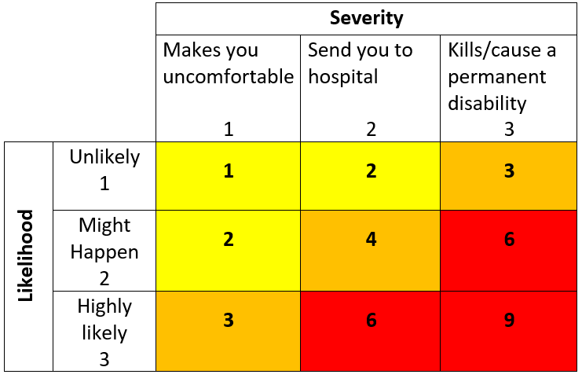  High Risk  Moderate Risk  Low Risk
Working Alone | -isolation  -lack of communication  in the event of emergency | 3 | 3 | 9 | H | EC: telephone, cell phone, radio, web camera  AC: training, organizing and planning work, rotation of workers, list of emergency contact numbers, U of L working alone procedure and login system; check in/out procedure, U of L Working on Campus Registry.
Working under unusual or unfamiliar circumstances | Psychosocial hazards  -Stress/fatigue  -anxiety | 2 | 2 | 4 | M | EC: key/card control, restricted access  AC: restricted access approval and procedures, training, organizing and planning work, rotation of workers, take regular breaks, rotating/modified work schedules (if applicable), Employee Family Assistance Program (EFAP); list of emergency contact phone numbers
Campus awareness | -hazards associated property damage or maintenance required | 2 | 2 | 4 | M | AC: report property damage and/or maintenance, report to Security and Facilities Services.
Research (Animal care, Wet labs, Magnetic Resonance Facility) | -Potential for exposure to viral airborne particles  -Potential for exposure to viral particles on surfaces | 2 | 2 | 4 | M | AC: social distancing (2 meters), hand hygiene, respiratory etiquette, training, individuals who are ill will be kept away from workplace, frequent cleaning of surfaces, minimize sharing of workstations, tools and equipment.  PPE:

(When describing the controls to reduce the risk associated with each hazard the above hierarchy must be followed, with personal protective equipment as the last means of control)

Probable exposure: is likely or most likely
Potential exposure: is existing in possibility, not in actuality.

By signing this form, you acknowledge that you understand the hazards and associated controls as outlined in this document:

Supervisor’s Name Supervisor’s Signature

Worker Name | Signature | Date

