October
2019 | 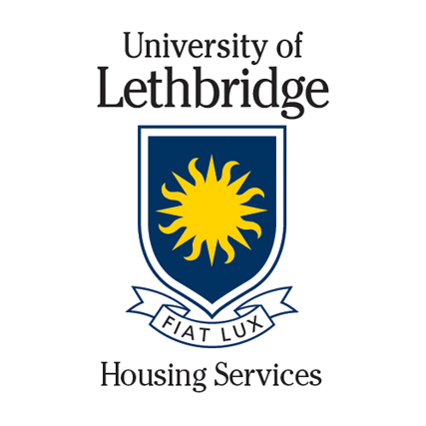
Sunday | Monday | Tuesday | Wednesday | Thursday | Friday | Saturday
 |  | 1 | 2 | 3 | 4  Community Helpers  See your RA for details | 5
 | Health and Safety Check: First Year Residences Only
6 | 7 | 8  Get Consensual Food and Film  4:30 pm  K111 | 9 | 10 | 11 | 12
Advising in Residence
4:30 pm
Blakiston Lounge
13 | 14 | 15 | 16 | 17 | 18 | 19
 | Thanksgiving  University Closed |  | Writing Centre & Library Intro  4:30 pm  Library Entrance  Health and Safety Check: First Year Residences Only
20 | 21 | 22 | 23 | 24 | 25 | 26
 |  | Reduce, Reuse, Recycle  4 pm | D4 |  |  | Community Helpers  See your RA for details
27 | 28 | 29 | 30 | 31 | 1 | 2
 | Health and Safety Check: Residence Wide |  |  | Halloween
Every time you attend an event, you get entered to win a prize at the end of the term!

