Proton Shimming Protocol for Bruker Spectrometers

This manual is intended to provide instructions on how to carry out automatic shimming on a Bruker spectrometer using the proton nucleus (H1), rather than deuterium (H2) lock channel. This is important to any user who needs to carry out solution-state work using a non-deuterated solvent.

Step-by-Step Instructions:

- Ensure that the temperature for the spectrometer is being controlled. This can be done by typing “edte” in the command line and hitting enter. This will bring up the temperature interface. The target temperature should be set and the probe heater should be on. NOTE: Slight variations in temperature can cause changes in NMR line shapes and will affect the spectrometers ability to shim properly.

- Ensure that the lock and sweep are off.

- Bruker has created an automation (au) program that calibrates and carries out shimming based on the proton channel of the spectrometer. This is the easiest way to shim using the proton signal and should always be attempted first. The au program can be run by typing “shim1h” in the command line and hitting enter.

- Once the automation program has completed you should acquire a spectrum and check that the shims are sufficient for your purposes. If the “shim1h” au program produced an error please jump to step 6.
NOTE: Please ensure that the digital resolution (FIDRES) for the data acquisition is sufficient. Remember that the digital resolution is given by the following equation:
$$FIDRES=\frac{1}{AQ}$$
The digital resolution is represented in units of “Hz per point” which means that a smaller value for FIDRES represents better digital resolution. This number is improved by increasing the acquisition time (AQ) where:
$$AQ=TD X DW \left(dwell time\right) \& DW= \frac{1}{SW (spectral width)}$$
This means that you can improve the digital resolution by either increasing the number of points (TD) or using a smaller spectral width (SW). An example of the effects of digital resolution on the NMR line shape can be seen in figure 1.
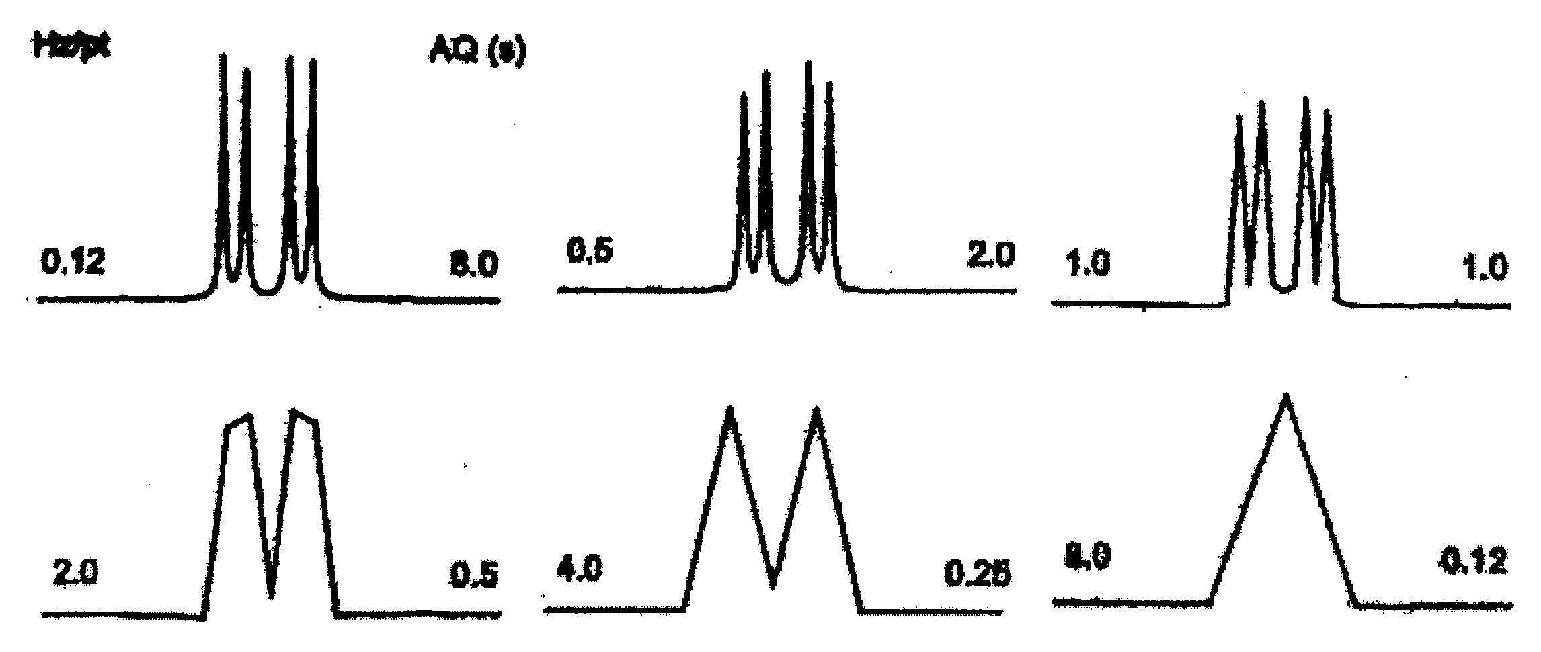
Figure 1 The effects of digital resolution on NMR line shape
- After the data acquisition is complete type “fp” in the command line and hit enter. This will process your spectra using a Fourier Transform and Phase Correction with NO exponential multiplication. The use of exponential multiplication should be avoided, as it causes line broadening effects that can hide distortions in your line shape due to insufficient shims. If the au program has provided “improved” but not “great” results you can simply re-run the au program once more. If the au program provides sufficient (“good”) results than you do not need to continue with the remaining steps of this manual. If the au program provided an error, or completed with a shim that is not good enough for your purposes you should move on to step 6 of this manual.

- Acquire a quick proton spectrum to determine the o1p to be used for the proton shimming. The value for o1p should correspond to the shift value for the proton peak in your spectrum in ppm units. If the proton spectra contains more than one peak you typically use the shift value corresponding to the largest peak in the proton spectra. Record this value in a notebook, as it will be used again shortly.

- Open the graphical user interface (GUI) for topshim by typing “topshim gui” in the command line and hitting enter. This should bring up the GUI shown in figure 2.
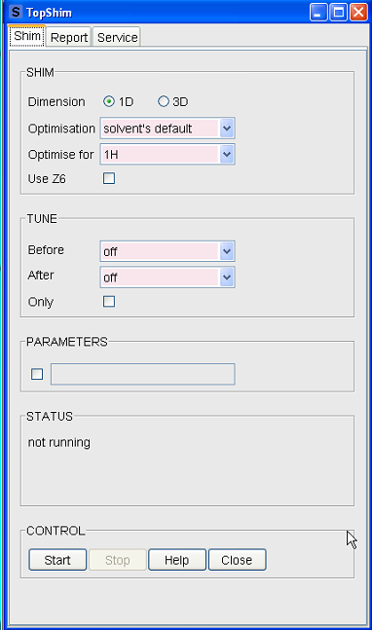

Figure 2 Topshim GUI

- You will need to select the box in the parameters section. This will allow you to pass additional commands that will be run when topshim is executed.

- Type the following commands into the box under the parameters section “1h lockoff convcomp o1p=<x-ppm>”. You will want to replace the <x-ppm> with the o1p shift value you recorded in step 6. NOTE: This value must be in ppm. Left click on the Start button to begin automatic shimming (found under the control box at the bottom of the GUI).
- Repeat steps 4 and 5 to obtain a spectrum of your sample. Check to ensure that you are satisfied with the end result of the shimming protocol. If you are happy with the shims then you are done with this manual, if not please proceed to step number 11.

- You must now manually shim the NMR magnet. NOTE: This is not an easy task and an inexperienced user should not attempt this step alone!!! If you have never manually shimmed the magnet contact your supervisor or someone from the facility staff to provide you with assistance. In order to manually shim you must first open up the interactive acquisition interface by typing “gs” in the command line and hitting enter (shown in figure 3).
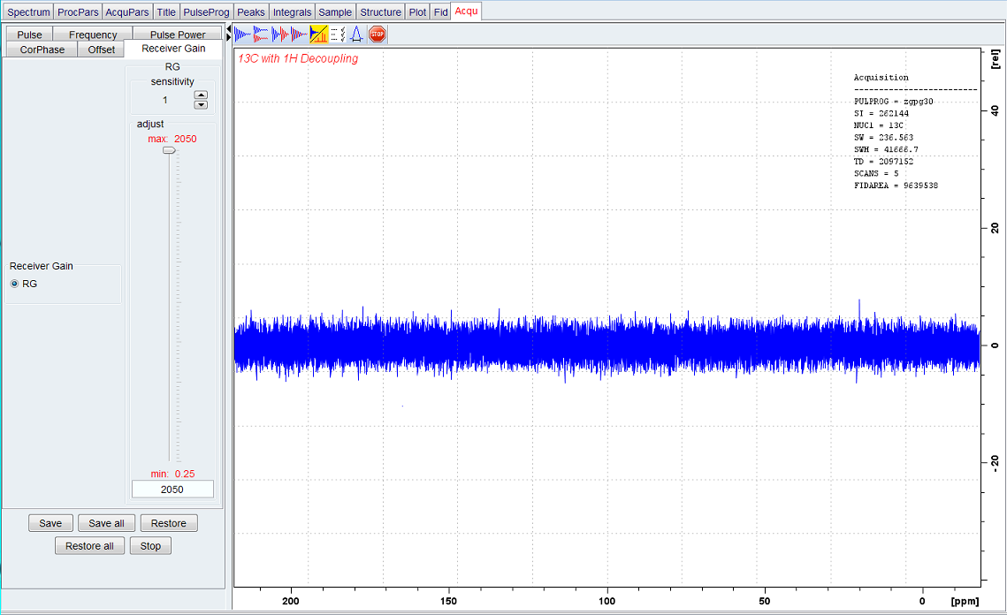
Figure 3 TopSpin Interactive Acquisition Interface
- Next you must open the BSMS panel and click on the “shims” tab in order to access the shim panel. The shim panel can be seen in figure 5.
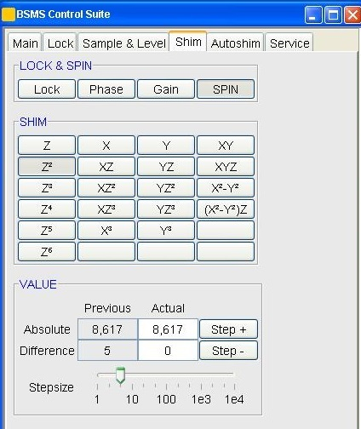
Figure 4 Shim tab of the BSMS panel

- Slowly and carefully adjust the longitudinal (Z) shims and check for the response. You should always start with the lowest order shim (Z) and work your way up to the highest order shim (Z5). If your changes are improving the shims you should see the FIDAREA that is reported on the top right corner of gs interface increasing. Conversely, if the area is decreasing your shim changes have had a negative effect.

- Once you have completed the longitudinal shims you should repeat steps 4 and 5 from above to check your line shape. If you are happy with your line shape you can stop here, if not you will need to proceed to the next step.
- Slowly and carefully adjust the transvers (X or Y) shims. You should really only need to adjust the X, Y, XZ, and YZ shims. Make sure to keep an eye on the FIDAREA as you adjust these shims, as it will tell you if your changes are having a positive negative effect on the line shape.
- The changes you make to the transverse shim will have an effect on the longitudinal shims. This means that you must now repeat step 13 to optimize the Z shims once again.
- Repeat steps 4 and 5 from above to check your line shape. If you are happy with your line shape you can stop here, if not you will need to go back to step 13 and repeat steps 13-17 until you are happy with your shim.

NOTE: Manual shimming is like a fine art! Its takes time and patience to master. Please be patient when shimming. Always remember to ask for help when you are unsure of what to do next!!

