2017 Counselling Camera report
Dr. Elaine Greidanus

The goal of this project was to identify video taping systems that were as simple to use as a laptop and camera, but with better video length, audio, and security. An additional goal is to develop a system that students may be able to sign-out and return, which a laptop is not a financially feasible solution.

In 2017 I trialed two cameras in my classes.

HTC-RE camera

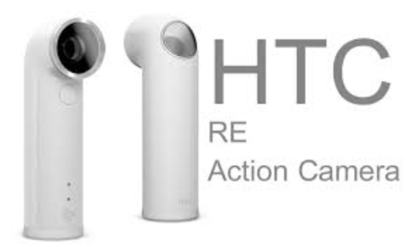

This camera was trialed in a class where a group had a discussion, similar to a group counselling session. The session was taped.
Results:
- The website suggested that the best way to access the media on the camera was through the RE App. This took a bit of setup and requires a password. While the password ensures some degree of security, it also adds a complication for students who may want to use the camera. They would need to download the app and have access to the password.
- When the video were viewed, the entire 1 hour session was not recorded in it’s entirety. There was one 20 minute segment and 3 >5 minute segments. I don’t know why this happened.
- Without the app, there is no way to preview the video without downloading the video onto a computer.
- The video quality was excellent. The sound was sufficient, but probably not much better than a laptop.
- This is a very strange camera.

Summary: Since the main goal of this project was to streamline the process of taping and reviewing video, the setup required for this camera makes it not ideal. The only redeeming feature of this camera is the wide-angle capture. The negatives outweigh the positives.

Canon Vixia HF R600
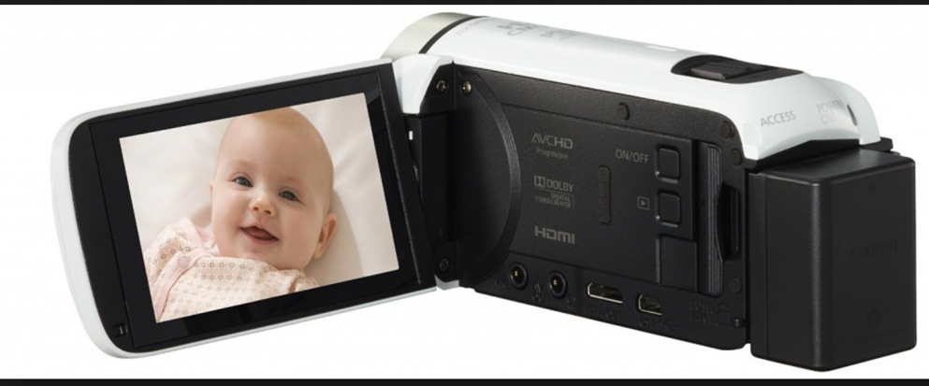

This camera was also trialed in a group counselling class.
Results:
- It was simple to use
- The video was also possible to preview on the camera itself (but the screen is not big enough or the audio quality sufficient that any student is ever likely to actually do this)
- The video captured was continual and easy to download onto a laptop
- The memory was sufficient for a single counselling session, but wouldn’t be sufficient for more than one session.

This camera is a decent version of a video camera. It’s video capture and audio are sufficient and perhaps somewhat better than a laptop. It would be more simple to sign out to students. The main downside of this camera for use in student practicums is that students would still need to download the videos to their laptops on a regular basis prior to previewing. Another downside is that it looks a lot like a videocamera, which is not ideal for clients who are nervous about being taped.

Next steps:
- This report will be presented at the Counselling Program meeting to the next of the counselling faculty meeting
- Request a trial using an ipad (which may have both the memory capacity and pre-viewing ability to improve on the student-laptop based system currently in place.) Funding for a ipad holder/tripod for this use may be requested.
- Return to HTC-RE to the Ed-tech group
- Retain the Vixia for use in classes, but not at practicum sites

