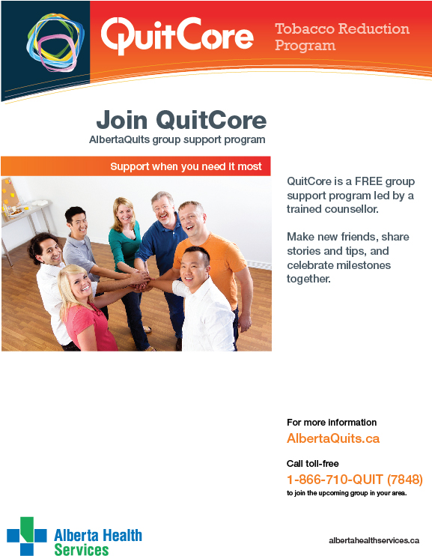

**Start Date:** September 13th, 2016

*\* Group runs weekly until October 18th \**

**Time:** 5:30 p.m. – 7:00 p.m.

**Location:**

Lethbridge Public Library- Main Branch

810 5th Avenue South, Lethbridge, AB

**Call 1-866-710-QUIT (7848) to register!**