2016-2017 Research Support Fund Outcomes
The University of Lethbridge received $2,153,028 in federal Research Support (RSF) Funding in 2016-2017.
The following chart provides an overview of how the funds were allocated under each of the five expenditure categories:
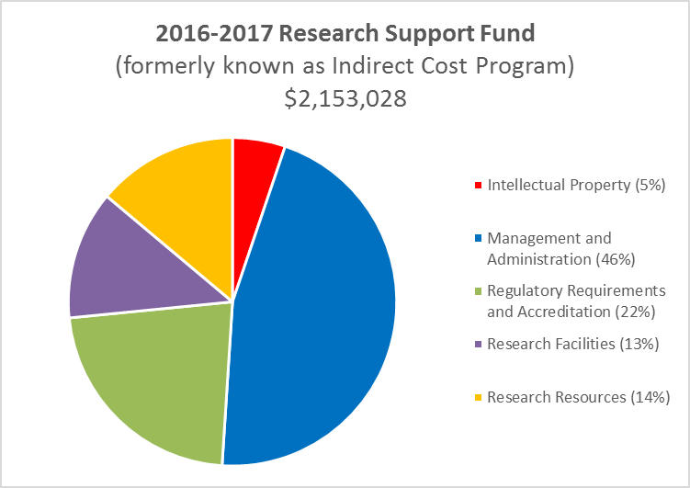

2016-2017 Performance Measures for Eligible Expenditure Areas
Eligible Expenditure Category | Institutional performance objectives | Indicator | Output | Outcomes reported at year end
Research facilities  Link:  http://www.rsf-fsr.gc.ca/administer-administrer/expenditures-depenses-eng.aspx#facilities | Increase research capacity by renovating and/or maintaining new and existing research facilities | Equipment and facilities that support research. | RSF will fund technical support required for maintaining the research facilities and operating costs for the research equipment. | The space devoted to research increased:  2015/16 – 20.49%  2016/17 – 20.70%
Research resources  Link:  http://www.rsf-fsr.gc.ca/administer-administrer/expenditures-depenses-eng.aspx#resources | Maintain library holdings needed by researchers | Dollars spent on electronic databases through the university budget | Database for use by researchers | Research Support Fund covers approximately 20% of the cost associated with the site license to the Canadian Research Knowledge Network.
Eligible Expenditure Category | Institutional performance objectives | Indicator | Output | Outcomes reported at year end
Management and administration of an institution’s research enterprise  Link:  http://www.rsf-fsr.gc.ca/administer-administrer/expenditures-depenses-eng.aspx#management | Continued support by Office of Research Services in the review and submission of grant applications | Number and quality of Tri-Council grant applications processed | RSF will fund a portion of the salaries of staff in Research Services, Financial Services, Human Resources and Information Technology that directly support researchers. | In 2016-2017 grant facilitators assisted with 204 applications with 102 successful applications which is a success rate of 50%.  Office of Research Services (ORIS) hosted five grant facilitation training sessions.  There was 96 new external grants/awards established in 2016-17.
Regulatory requirements and accreditation  Link:  http://www.rsf-fsr.gc.ca/administer-administrer/expenditures-depenses-eng.aspx#requirements | Continued vigilance and oversight of regulatory requirements | Time to achieve approval for animal or ethics protocols.  Level of animal care training. | RSF will fund staff infrastructure required for animal care, ethics and safety. | There 130 animal ethics approvals and 239 human subject ethics approvals.  Training included both ethics training course and hands on workshops and training.  Maintained compliance with regulatory standards.
Intellectual property (IP) and knowledge mobilization  Link:  http://www.rsf-fsr.gc.ca/administer-administrer/expenditures-depenses-eng.aspx#intellectual_property | Continue to provide service and support to researchers and external partners in knowledge mobilization. | Number of staff supporting intellectual property | RSF will fund a portion of the compensation for IP staff. | There were no new patent applications however there was one copyright registration and staff provided 26 workshops/training session.

