2015-2016 Research Support Fund Outcomes
The University of Lethbridge received $2,009,410 in federal Research Support (RSF) Funding in 2015-2016.
The following chart provides an overview of how the funds were allocated under each of the five expenditure categories:
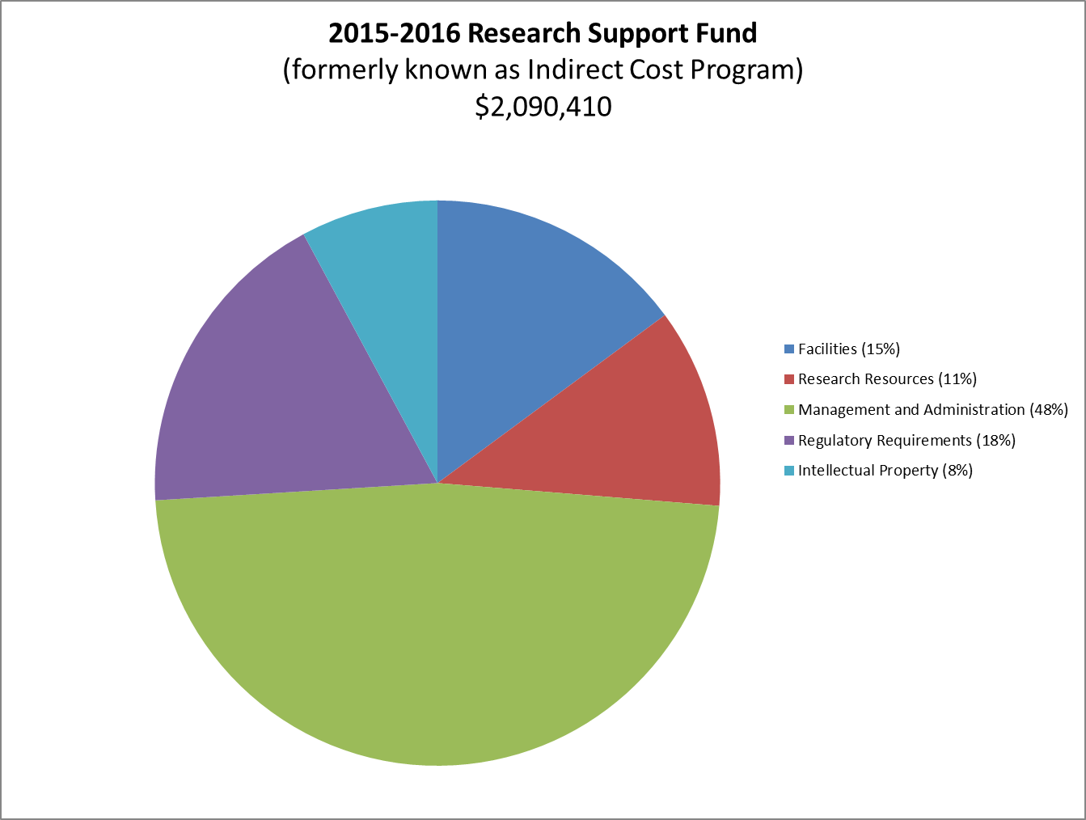
In 2015/16 the University of Lethbridge invested the Research Support Fund in:
Facilities: The funding was used for technician compensation used to support the research facilities and for facilities management to defray the cost of heat, lighting and electricity for the research space.
Resources: The funding was used to partially fund the cost of electronic journals and databases required by faculty and students and a small portion of the costs associated with insuring research equipment.
Management and Administration: The indirect cost program is critical in maintaining the support infrastructure required for the research enterprise. The staff support the researchers in all aspects of research administration including grant applications, grant administration, reporting and knowledge requirement compliance requirements. This investment has been instrumental in the success rate of grant applications.
Regulatory requirements: This area of support has increased significantly over the past few years. There has been a significant investment in animal care and safety training.
Intellectual property and commercialization: This funding was used to fund a positon that supports these commercial activities.

2015-2016 Performance Measures for Eligible Expenditure Areas
Eligible Expenditure Category | Institutional performance objectives | Indicator | Output | Outcomes reported at year end
Research facilities  Link:  http://www.rsf-fsr.gc.ca/administer-administrer/expenditures-depenses-eng.aspx#facilities | Increase research capacity by renovating and/or maintaining new and existing research facilities | Equipment and facilities that support research. | RSF will fund technical support required for maintaining the research facilities and operating costs for the research equipment. | The space devoted to research in 2015/16 is equivalent to 2014/15.
Research resources  Link:  http://www.rsf-fsr.gc.ca/administer-administrer/expenditures-depenses-eng.aspx#resources | Maintain library holdings needed by researchers | Dollars spent on electronic databases through the university budget | Database for use by researchers | Research Support Fund covers approximately 20% of the cost associated with the site license to the Canadian Research Knowledge Network.
Management and administration of an institution’s research enterprise  Link:  http://www.rsf-fsr.gc.ca/administer-administrer/expenditures-depenses-eng.aspx#management | Continued support by Office of Research Services in the review and submission of grant applications | Number and quality of Tri-Council grant applications processed | RSF will fund a portion of the salaries of staff in Research Services, Financial Services, Human Resources and Information Technology that directly support researchers. | In 2015/16 grant facilitators assisted with 41 applications which resulted in success rate of 63%.  Office of Research Services (ORIS) hosted a SSHRC Adjudicators meeting to discuss recent SSHRC Insight grant adjudication meetings.
Regulatory requirements and accreditation  Link:  http://www.rsf-fsr.gc.ca/administer-administrer/expenditures-depenses-eng.aspx#requirements | Continued vigilance and oversight of regulatory requirements | Time to achieve approval for animal or ethics protocols.  Level of animal care training. | RSF will fund staff infrastructure required for animal care, ethics and safety. | 228 protocols reviewed (144 human research protocols, including annual renewals; and 84 animal research protocols, including annual renewals)  ORIS hosted a series of Animal Research Ethics and Human Research Ethics workshops for graduate students.
Eligible Expenditure Category | Institutional performance objectives | Indicator | Output | Outcomes reported at year end
Intellectual property (IP) and knowledge mobilization  Link:  http://www.rsf-fsr.gc.ca/administer-administrer/expenditures-depenses-eng.aspx#intellectual_property | Continue to provide service and support to researchers and external partners in knowledge mobilization. | Number of staff supporting intellectual property | RSF will fund a portion of the compensation for IP staff. | 0 increases in patent applications for the period.

